United States History 2020-2021
~Mr. Leonhart~
Phone: 352-797-7075 ext. 239 | Email: leonhart_m@hcsb.k12.fl.us

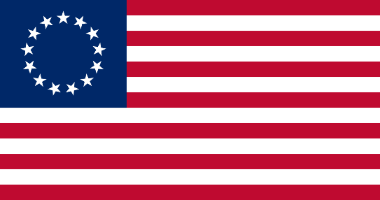

Class Description: Students will study American history from the Exploration and Colonization period to the Reconstruction Period following the Civil War. Students will be able to pass the district developed 9 Weeks exam following each term after successfully completing each term.

Required Materials:
- #2 Pencil
- Highlighter
- A folder or binder
- Loose leaf paper

Grading:
- 30% Classwork
- 20% Extension Activities
- 10% Homework
- 40% Summative

Textbook:
- Succeeding in Early U.S. History- Companion Work Text for Mastering Florida Assessments

School-Wide Classroom Policies
- Be on time and prepared for class with notebook, paper, pen and pencil.
- No gum, candy, food, drinks, or toys in class.
- Raise your hand for permission to speak or move from the seat. Stay seated until dismissed by the teacher.
- Avoid name-calling and refrain from making threats. Threats will be taken seriously and can result in OSS. Keep your hands and feet to yourself and respect each other.
- Clean up any tools or areas that you have been using.
- Students should not have any electronic devices (unless given permission).

Classroom Expectations:
- Students will be actively involved in all classroom discussions and group projects.
- Students will be team players in accomplishing group, class, and school goals.
- Students will treat the teacher and classmates with respect, especially during classroom discussions.
- Students are expected to complete assigned homework and be prepared for class discussions on a daily basis.

Late Work Policy: All assignment should be completed and turned in by the due date. Students have two days to make up an assignment for each excused absence day. For late work and unexcused absence assignments turned in late, 5 points will be deducted each day it is not turned in. Please see the HCSB Middle School Procedure Handbook for additional information about absences. Please call or email if you have any questions.

Online Resources:
- United States History Online Textbook (use single sign on): https://connected.mcgraw-hill.com
  - Single Sign On: firstname.lastname@hernandoschools.org
- Quizlet: https://quizlet.com
- Kahoot: https://kahoot.it//

How to Ensure Your Student is Successful in US History:
- Check grades on www.skyward.com regularly.
- Students should use materials (video clips, notes, graphic organizers, projects, etc.) to review previously learned materials on a daily basis.
- Have student use Kahoot and Quizlet regularly to prepare for quizzes and tests.
- Students have the option to pre-read online textbook before we begin each chapter and review what we went over each day for 10-15 minutes.

---------------------------------------------------------------
Please return this slip to Mr. Leonhart.

I have received and read a copy of the Syllabus and Classroom Procedures for United States History.

Class Period _______

__________ _________________________ _________________________
Date Student’s Name (Printed) Parent or Guardian Name (Printed)

__________ _________________________ _________________________
Date Student Signature Parent or Guardian Signature

